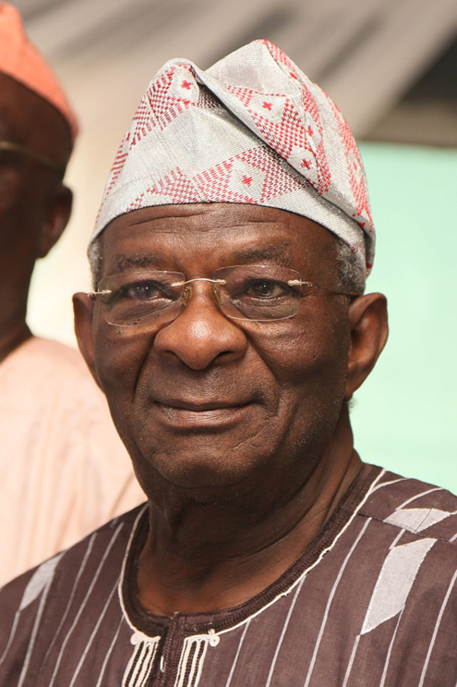
Condolence Message

The Chairman, members and entire staff of the Secretariat of the Nigeria Governors’ Forum (NGF) join Nigerians in offering our deepest sympathy to the Governor of Lagos State over the passing away of his father, Alh. Abdulrasheed Ademola Fashola on Monday, 5th August 2013. We are indeed saddened by this irreplaceable loss and pray especially for you, your family and the entire people of Lagos states at this very difficult period of grief. God will comfort you and grant you the grace to bear this loss and strength to remain steadfast.
In Sympathy,

A. B Okauru Esq
Director General
Nigeria Governors’ Forum

